**Guide to Rotary Giving (and what happens next)**

**December 2017**

**1 - Introduction**

Rotary International (RI), District 7360 and our club each have foundations or funds to which donations can be contributed or accumulated. Some of these also allow withdrawals and / or return all or part of the principal contribution to the District and potentially the club after a period of time.

Most folks, even those who’ve been in Rotary for a while and worked with assorted foundations, get confused trying to figure out how contributions to different parts are used, what credit is afforded the contributor and their club, and if some is returned, how much and when. It was noted at a recent board meeting that member's inclination to give, if able, would be enhanced if they understood more about it.

 

This paper attempts to clarify both Rotary Giving and what happens to donations. A very simple explanation of the RI Foundation can be found at [www.rotary.org/en/why-rotary-best-steward-your-money](https://www.rotary.org/en/why-rotary-best-steward-your-money). For those who want more, especially below RI, read on. The early portions are still fairly simple, concentrating on the overall structure of Rotary Foundations available to the club. We get more detailed the further you read, including discussions of matching funds and District Grant club allocations. There are also references to additional material carried over from the original sources. We’re cutting and pasting from many of sources, mostly Rotary, so there is no claim of originality here. The material is divided into these sections:

**Section Page**

**1 - Introduction**  **1**

**2 - Rotary Foundation (RF) Structure 2**

**3 - What Happens to Money in the RF Funds 3**

**4 - District Designated Fund (DDF) 4**

**5 - Club Foundation 5**

**6 - Employing Rotary Funds at All Levels to Achieve**

**Community and International Objectives 5**

**7 - Recognition for Contributions 8**

**2 - Rotary Foundation (RF) Structure**

The RF is organized separately from the RI structure with its own directors. Its purpose is to manage the foundation's funds. For the most part, the entire Rotary Structure (clubs and supporting overhead) is the source for contributions to achieve Rotary International objectives.

RF reports contributions to three funds and an “Other” category shown below. Contributions for 2015 - 2016 and the cumulative value of each at a point in time is shown below.

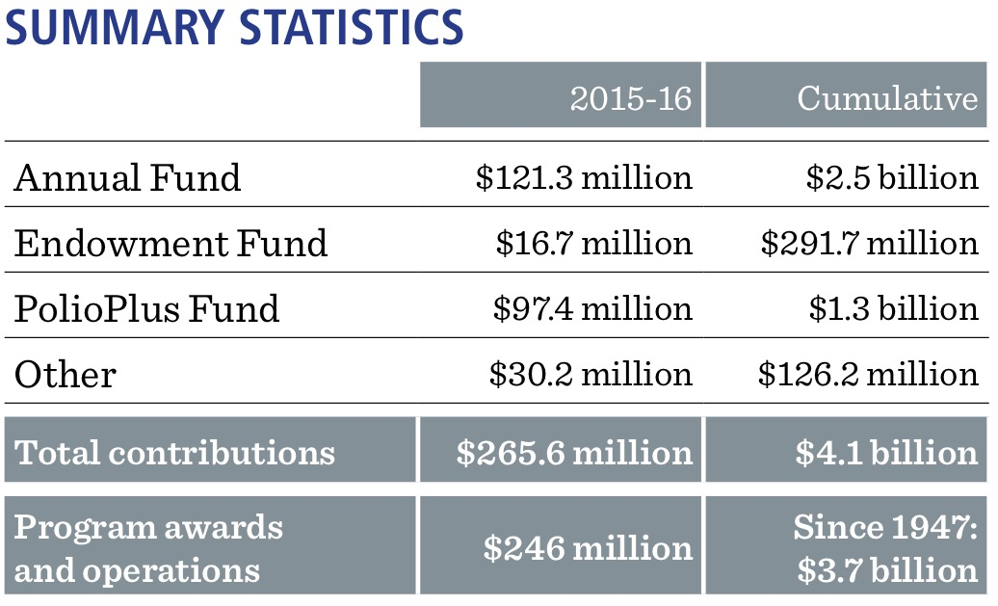

**ANNUAL FUND**

Foundation grants and activities achieve good in the world. The Annual Fund is the main funding source for Rotary grants and activities. The “Every Rotarian, Every Year” initiative encourages every member to participate in a Foundation project and contribute to the Annual Fund every year. Recognition is available to those who support the Annual Fund (see below).

**ENDOWMENT FUND**

The Endowment Fund ensures the long-term viability of the Foundation’s grants and programs. Contributions to the Endowment Fund are invested in perpetuity. A percentage of the total value of the fund is directed annually to Foundation grants and programs. Donations to the Endowment Fund tend to be of substantial size and can be outright cash contributions, stocks, and other securities, bequests, or life-income agreements. Club members who want to support the Rotary Peace Centers can make a gift to that program through the Endowment Fund.

**POLIOPLUS FUND**

Club members are encouraged to make contributions to the PolioPlus Fund, which helps to continue immunization efforts until the world is declared polio-free. Despite the enormous resources already committed, more money is urgently needed to reach all children in the remaining polio-endemic countries. Grants made from this fund help pay for National Immunization Days and surveillance activities.

**FUNDS FROM THE COMMUNITY**

While many of our contributions come from members, the communities in which we live also contribute through fundraisers and independent donations. For more information, see the fundraising section in Lead Your Club: Service Projects Committee.

**3 - What Happens to Money in the RF Funds**

The chart below shows how the RF distributed one year's worth of resources in the RI funds.

The RF uses the money contributed for a variety of purposes. Contributions to the PolioPlus Fund remain aligned with the fight to eradicate Polio as outlined above. There is not a lot of information on Community funds other than that they come from people and organizations outside Rotary. One would assume these funds come with or without strings. Except to the extent they achieve their (and our) broad objectives, neither of these directly impact our district or our club.



The Annual and Endowment Funds, on the other hand, work together to support Global and District Grants. The Endowment’s role is straight forward. RF does not touch the principal, but does designate a portion the fund’s total value for Global Grants and programs each year.



The Annual Fund is slightly more complicated (see chart below). 100% of our Annual Fund contributions are held by the RF for three years.

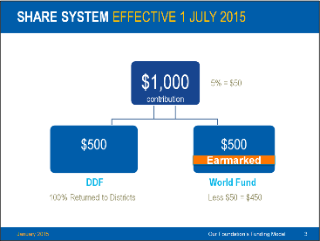

At the end of that time 50% percent (less a potential 5% for overhead) goes to a World Fund. The 5% acts as a shock absorber to steady cash available each year for expenses and an operating reserve. It is only used if investment returns are not as expected and won’t cover these requirements. They otherwise stay in the World Fund. In the final step, the World Fund is measured to ensure that it contains 50 percent of the three prior years’ worth contributions, plus $5 million – a growth factor. Then and only then are surplus funds transferred to the Endowment Fund.

More important for clubs, the other 50 % is returned to 7360's "District Designated Funds" (DDF) via the SHARE program. Worldwide District Grants for 2015 - 2016 are summarized below.



**4 - District Designated Fund (DDF)**

Unlike our club and RI, District 7360 does not have a foundation. Instead it has a District Designated Fund (DDF) and a small board of directors who act as its stewards. It is organized separately from the District structure. Its funds source is the 50% share returned to our District's DDF from club contributions three years prior (see above). According to RI guidelines, our DDF can use half of these funds for District Grants and half for Global Grants.

The amount available in the DDF each year varies based on the club contributions three years prior, and the amount left over in the DDF from the previous year, if anything. This means DDF directors must vary what they can make available to clubs for Global and District Grants each year.

To make use of the DDF, clubs must ask for Global or District Grants. For District Grants, since there are generally about 75 clubs in the district, DDF directors must adjust how much is available to each club each year. The current policy provides each club one District Grant a year valued at 25% of their contribution three years before, or a minimum of $500. In prior years a flat cap per club has been used (for example, $112,500 / 75 = $1500 each) so the current policy is a great improvement.

Clubs may apply for up to nine Global Grants per year. The DDF matches a club's project contributions between 25% and 100% depending on the size of the project and Global Grant funds available. The District Governor and DDF Committee approve applications and level of matching. In addition, each year the District Governor may pick one Global District project to support.

**5 - Club Foundation**

Like the Rotary Foundations discussed above, it is separate from the club structure, but exists to support the club's objectives. The club is not a 501c3 organization, but the club foundation is.

Also as above, our club has a foundation consisting of several funds. Two of these funds are for scholarships: our Thompson "needs based" scholarship with approximately $265K in assets, and the newer Merit scholarship which has grown through contributions to over $30K. Resources in these funds are effectively endowments. Their use is restricted to the respective scholarships, and expenses are paid from earnings without touching the principal.

The third element is a general fund currently consisting of roughly $105,000. All the money we raise through Battle of the Minds and other fund raising activities goes into the general fund. We use these funds to pay our Battle Co-Sponsors, buy dictionaries and books for Read Across America, replace the Rotary Sign and the playground equipment in Rotary Park, and other community support activities.

**6 - Employing Rotary Funds at All Levels to Achieve Community and International Objectives**

At the club level, we have access to all three levels of foundations via Global and District Grants, and from our own foundation. Each has its own rules and criteria. We'll not spend a lot of time on our own foundation as we are free (within the bounds of state and federal law and the scholarship fund restrictions) to use these funds as we choose.

**Global Grants**

Global grants support large international activities with sustainable, measurable outcomes in Rotary’s areas of focus. By working together to respond to real community needs, clubs and districts strengthen their global partnerships. For US clubs, Global Grants are not restricted to projects in other countries. US clubs can also be the beneficiary.

Read ‘A Guide to Global Grants’ for detailed information on planning your project, applying for a grant to fund it, carrying it out, and reporting on your progress and outcome.

***What global grants support***

Global grants can fund:

* Humanitarian projects
* Scholarships for graduate-level academic studies
* Vocational training teams (VTTs), which are groups of professionals who travel abroad either to teach local professionals about their field or to learn more about it themselves

***How they’re funded***

Global grants are funded by The Rotary Foundation from the World Fund, and awards range from US$15,000 to $200,000. The minimum budget for a global grant project is $30,000.

Matching funds is perhaps the best reason to use Global Grants. The Foundation matches cash at 50 percent and DDF contributions at 100 percent. The Foundation will match non-Rotarian contributions toward a grant at 50 percent, provided they do not come from a cooperating organization or a beneficiary of the project. At least 30 percent of contributions (including all cash and DDF contributions to be matched by the Foundation) to global grants funding humanitarian projects must come from outside of the project country. Host sponsors for humanitarian projects are encouraged to contribute toward the financing of the grant.

Clubs and districts contribute District Designated Funds (DDF) and/or cash contributions that the World Fund matches. DDF is matched 100 percent and cash is matched at 50 percent.

***Qualification***

Both the district or club in the country where the activity is carried out and the international partner district or club must first become qualified before applying for a global grant. This is mainly a function of getting the district staff and two club members certified to submit grants each year, and the club president signing some documents accepting responsibility for grant funding. Learn more about the qualification process at rotary.org or contact the District Foundation. Your club and district Rotary Foundation chairs can help you plan how to use your District Designated Funds and learn how to qualify your club.

***Submitting a successful grant application***

Consult with local experts early in the planning process to build a strong project plan and global grant application. The district resource network (see below) can help.

To be approved, your application must clearly describe how your project, scholarship, or vocational training team:

* Is sustainable — include plans for long-term success after the global grant funds have been spent
* Includes measurable goals
* Aligns with one of Rotary's areas of focus
* Responds to real community needs
* Actively involves Rotarians and community members
* Meets the eligibility requirements in the grants terms and conditions

Applications are accepted throughout the year and are reviewed as they're received. Learn more about the Global Grant Lifecycle.

Note: Applications for scholars who will begin studies in August, September, or October must be submitted by 30 June.

***Monitoring & evaluation***

Measuring outcomes is an integral part of global grant projects. Proper monitoring and reporting ensure that Rotary grants have a positive impact.

Learn more in the Global Grant Monitoring and Evaluation Plan Supplement.

***District resource network***

Local Rotarians who have expertise in Rotary’s areas of focus, global grants, and project planning are among your best resources. Experts can also include alumni, Rotaractors, Rotarian Action Group members, and The Rotary Foundation Cadre of Technical Advisers.

Contact your district international service chair for help connecting with the district resource network: local subject matter and project experts. If your district hasn’t appointed a committee chair, work with your district governor or write to rotary.service@rotary.org.

**District Grants**

District grants fund small-scale, short-term activities that address needs in your community and communities abroad. Each district chooses which activities it will fund with these grants.

***What district grants support***

You can use district grants to fund a variety of district and club projects and activities, including:

* Humanitarian projects, including service travel and disaster recovery efforts
* Scholarships for any level, length of time, location, or area of study
* Youth programs, including Rotary Youth Exchange, Rotary Youth Leadership Awards (RYLA), Rotaract, and Interact
* You have plenty of freedom to customize your service projects. Refer to the Terms and Conditions for Rotary Foundation District Grants and Global Grants for information about district grant requirements.

***How they’re funded***

District grants are funded by The Rotary Foundation solely with allocations from the District Designated Fund (DDF). A district may apply for a single grant each Rotary year to support one or more projects using up to 50 percent of the district’s SHARE allocation, which represents 50 percent of its annual giving from three years’ prior plus any Permanent Fund-SHARE earnings.

Districts receive this funding as a lump sum and then distribute it to their clubs. In District 7360 this distribution to clubs is accomplished by establishing a cap for each club based on the amount available annually in the District Designated Fund. District Grants match 100% of funds provided by clubs for their projects, providing a means of extending club resources on behalf of their communities.

Individual clubs may request their portion by asking for a district grant per district guidelines.

***Qualification***

Districts need to become qualified to apply for district grants. This is mainly a function of getting two club members certified to submit grants each year, and the club president signing some documents accepting responsibility for grant funding. Learn more about the qualification process at rotary.org or contact the District Foundation.

***How clubs request funds***

If your club is seeking district grant funding, you can apply directly to your district. Individual districts administer their own district grant programs. Check with your district to find out about available funding, application forms and guidelines, deadlines, and any other requirements.

**7 - Recognition for Contributions**

Your generous contributions to [**The Rotary Foundation**](https://www.rotary.org/en/about-rotary/rotary-foundation) (www.rotary.org/en/about-rotary/rotary-foundation) are essential to securing and growing Rotary programs throughout the world. We recognize donors to express our gratitude for your commitment, offering individual and club recognition as well as naming opportunities that enable you to honor a friend or family member with a named or endowed gift.

***Individual recognition***

***Rotary Foundation Sustaining Member***

When you give $100 or more per year to the Annual Fund.

***Benefactor***

When you include the [**Endowment Fund**](https://www.rotary.org/en/rotary-endowment) (www.rotary.org/en/rotary-endowment) as a beneficiary in your estate plans or when you donate $1,000 or more to the fund outright. Benefactors receive a certificate and insignia to wear with a Rotary or Paul Harris Fellow pin.

***Paul Harris Fellow***

When you give $1,000 or more to the Annual Fund, PolioPlus, or an approved Foundation grant. To recognize someone else as a Paul Harris Fellow, you can give that amount in their name. Learn more about [**Paul Harris Fellow recognition**](https://www.rotary.org/en/history-paul-harris-fellow-recognition) (www.rotary.org/en/history-paul-harris-fellow-recognition).

***Multiple Paul Harris Fellow***

When you give additional gifts of $1,000 or more to the Annual Fund, PolioPlus, or an approved Foundation grant.

***Paul Harris Society member***

When you elect to contribute $1,000 or more annually to the Annual Fund, PolioPlus, or an approved Foundation grant. Learn more about the [**Paul Harris Society.**](https://www.rotary.org/en/about-rotary/history/paul-harris-society) **(www.rotary.org/en/about-rotary/history/paul-harris-society)**

***Bequest Society member***

When you give $10,000 or more via your estate plans. Bequest Society members are recognized with an engraved crystal recognition piece and a Bequest Society pin. Recognition items commemorate giving at these levels:

* Level 1: $10,000 to $24,999
* Level 2: $25,000 to $49,999
* Level 3: $50,000 to $99,999
* Level 4: $100,000 to $249,999
* Level 5: $250,000 to $499,999
* Level 6: $500,000 to $999,999
* Level 7: $1,000,000 to $2,499,999
* Level 8: $2,500,000 to $4,999,999
* Level 9: $5,000,000 to $9,999,999
* Level 10: $10,000,000 and above

***Major Donor***

When your cumulative donations reach $10,000. Major Donors can choose to receive a crystal recognition piece and a Major Donor lapel pin or pendant. NOTE: Name recognition is not automatic and needs to be reported to [**RI staff**](mailto:majordonorcoord@rotary.org) (majordonorcoord@rotary.org). Recognition items commemorate giving at these levels:

* Level 1: $10,000 to $24,999
* Level 2: $25,000 to $49,999
* Level 3: $50,000 to $99,999
* Level 4: $100,000 to $249,999

***Arch Klumph Society***

When your cumulative donations reach $250,000. Recognition includes an induction ceremony and your picture and biography in the Arch Klumph Society interactive gallery at the Rotary International headquarters in Evanston, Illinois, USA. You also receive invitations to society events, along with membership pins and crystals that commemorate giving at the following levels. Learn more about the [**Arch Klumph Society**](https://www.rotary.org/en/about-rotary/history/arch-klumph-society). (www.rotary.org/en/about-rotary/history/arch-klumph-society)

* Trustees Circle: $250,000 to $499,999
* Chair’s Circle: $500,000 to $999,999
* Foundation Circle: $1,000,000 to $2,499,999
* Platinum Trustees Circle: $2,500,000 to $4,999,999
* Platinum Chair’s Circle: $5,000,000 to $9,999,999
* Platinum Foundation Circle: $10,000,000 and above

***Club banner recognition***

***100% Paul Harris Fellow Club***

For clubs in which all dues-paying members are Paul Harris Fellows. This is a one-time recognition.

***100% Paul Harris Society Club***

For clubs in which every dues-paying member contributes a minimum of $1,000 to the Annual Fund, PolioPlus, or global grants within a Rotary year

***100% Foundation Giving Club***

For clubs that achieve an average of $100 in per capita giving and 100 percent participation, with every dues-paying member contributing at least $25 to any or all of the following during the Rotary year: Annual Fund, PolioPlus Fund, approved global grants, or [**Endowment Fund**](https://www.rotary.org/en/rotary-endowment). (www.rotary.org/en/rotary-endowment)

***Every Rotarian, Every Year Club***

For clubs that achieve a minimum Annual Fund contribution of $100 per capita during the Rotary year, and every dues-paying member must personally contribute at least $25 to the Annual Fund during the year.

***Top Three Per Capita in Annual Fund Giving***

For the three clubs in each district that give the most, per capita, to the Annual Fund. Clubs that give at least $50 per capita are eligible.

***Naming opportunities***

Special naming opportunities are available for endowed and term gifts to recognize the donor or a loved one. Endowed gifts are invested in perpetuity, with a portion of their earnings spent on a designated program. Term gifts are spent in their entirety for a specific purpose over an agreed period of time.

***Endowment naming opportunities***

* $1 million or more: Fund established in consultation with the donor
* $500,000 or more: Fund that can provide support for a participating district, an area of focus, or a desired location
* $250,000 or more: Fund that can provide support for a participating district and an area of focus
* $25,000 or more: Fund that provides general support for an area of focus
* $25,000 or more: Fund designated to the World Fund or SHARE

[**Learn more**](https://www.rotary.org/en/rotary-endowment) **(www.rotary.org/en/rotary-endowment)**

***Term global grants naming opportunities***

* $30,000: A one-time gift that can provide support for a participating district and an area of focus
* $15,000: A one-time gift that can provide general support for an area of focus

***Rotary Peace Centers endowment opportunities***

* $1.5 million: Supports one two-year fellow at a Rotary Peace Center every year
* $1 million: Supports one two-year fellow at a Rotary Peace Center every two years
* $1 million: Supports a visiting lecturer at a Rotary Peace Center every year
* $750,000: Supports one two-year fellow every three years
* $500,000: Supports one two-year fellow at a Rotary Peace Center every four years
* $250,000: Supports one certificate program fellow every year
* $100,000: Supports annual seminar at a Rotary Peace Center every year
* $25,000 and up: Fund that provides general support to the Rotary Peace Centers

***Rotary Peace Centers term gift opportunities***

* $75,000: Supports a term two-year Rotary Peace Fellow at a Rotary Peace Center
* $75,000: Supports up to 10 applied field internships or research projects for a specific class of fellows at a Rotary Peace Center
* $60,000: Supports one year of funding for five certificate program fellows
* $10,000: For general support of the program